DATA MIGRATION & REPORTING

THE DATA MIGRATION DISASTER

A bank migrated customer data over weekend. Monday: 5000 customers missing. 2000 duplicates. Why? The BA wrote: 'Move customer data.' Developer moved ALL records, even test accounts.
Lesson:Data migration needs surgical precision.

Reality: "90% of migration projects fail on data quality, not technology.

ETL PROCESS

ETL = Extract, Transform, Load

Step 1: Extract (GET the data)
```
FROM: Old CRM, Excel, Legacy systems
QUESTIONS:
• What tables/fields?
• How much data? (10K vs 10M records)
• How to extract? (Full vs incremental)
```

Step 2: Transform (CLEAN the data)
```
FIX:
• Duplicates (John Doe vs J. Doe)
• Formats (555-1234 vs (555) 123-4567)
• Errors (Invalid emails, future birth dates)
```

Step 3: Load (PUT the data)
```
TO: New CRM, Data warehouse
RULES:
• Load order (Accounts before Contacts)
• Validation (Check after loading)
• Rollback plan (If fails, go back)
```

Live Example: Migrating Customer List

Old System (Excel):
```
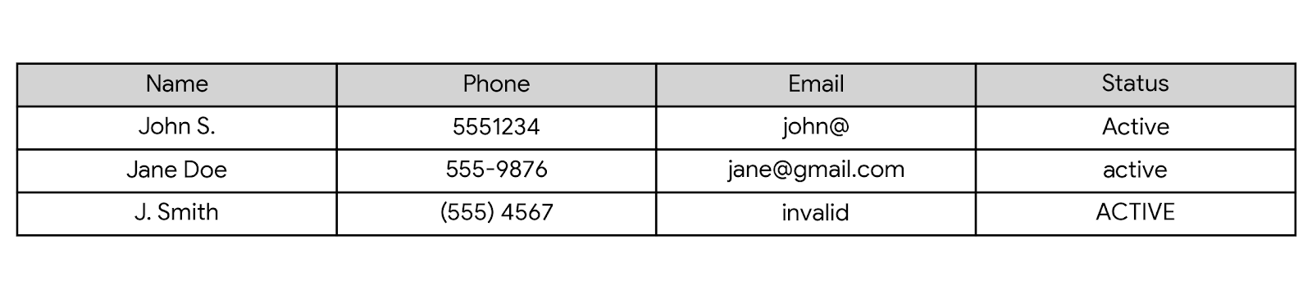```

Problems Found:
1. Inconsistent name formats
2. Missing email domain
3. Phone formats differ
4. Status case mismatch

Transformation Rules:
1. Names: Title Case (john → John)
2. Phone: Standardize to XXX-XXX-XXXX
3. Email: Validate format, reject invalid
4. Status: Convert to uppercase

---

DATA MAPPING DOCUMENT

The BA's Most Important Migration Tool

Simple Template:
SOURCE → TARGET → RULE → NOTES
```
Live Build: Customer Migration Mapping

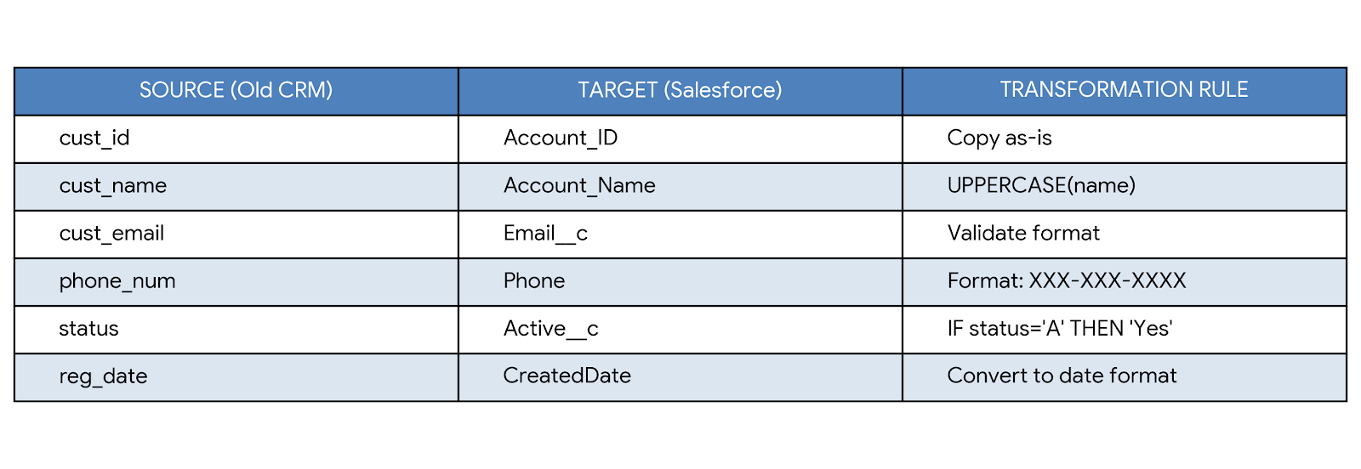

Common Transformation Rules:

1. Format Changes:
- `UPPERCASE()` - Convert to uppercase
- `TRIM()` - Remove extra spaces
- `FORMAT_PHONE()` - Standardize phone format

2. Value Mapping:
Old Value → New Value
"A" → "Active"
"I" → "Inactive"
"N" → "New"

3. Calculations:
- `CONCAT(first, " ", last)` - Combine names
- `DATEDIFF()` - Calculate age from birth date
- `IF-THEN-ELSE` - Conditional logic

Exercise: Product Data Migration

Old System:
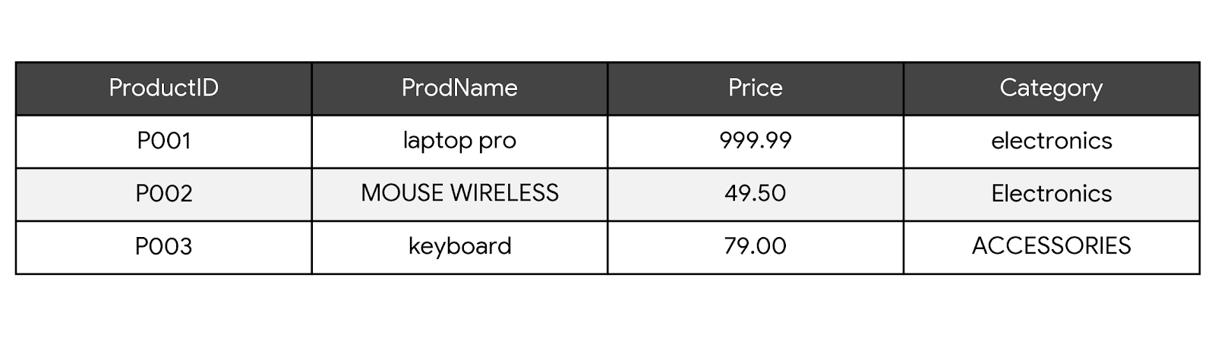```

New System Needs:
- Product_Code (uppercase)
- Product_Name (title case)
- Price (rounded to 2 decimals)
- Category (standardized list: Electronics, Accessories, Software)

Task: Create mapping document with transformation rules.

---

BA ROLE IN DATA MIGRATION

The 4 BA Responsibilities:

1. Data Profiling (What do we have?)
Ask:
• How many records?
• What % missing data?
• How many duplicates?
• Any invalid values?
```

2. Quality Rules (What's acceptable?)
Define:
• Email must have @ and .
• Phone: 10 digits
• Required fields: Not empty
• Dates: Not in future
```

3. Testing Strategy (Did it work?)
Test Levels:
1. Sample data (100 records)
2. Full volume test
3. User acceptance test (UAT)
```

4. Cutover Planning (Go-live plan)
Weekend Plan:
Friday 6 PM: Stop old system
Saturday: Run migration
Sunday: Validate, fix issues
Monday 6 AM: New system live
```

Migration Risk Checklist:
□ Data loss (missing records)
□ Data corruption (wrong values)
□ Performance (takes too long)
□ Rollback plan (if fails)
□ Business impact (downtime acceptable?)

---

PRACTICAL - CUSTOMER MIGRATION

Scenario: "GlobalTech" Moving from Old CRM to Salesforce

Current System: Custom-built CRM (10 years old)
Target System: Salesforce
Data Volume: 50,000 customers, 200,000 contacts

Step 1: Data Assessment
Sample Issues Found:
• 15% missing email addresses
• 2000 duplicate customers (same company, different spelling)
• Phone numbers in 5 different formats
• Inactive customers not flagged (30% haven't bought in 2 years)

Step 2: Create Mapping Document

SOURCE FIELD | TARGET FIELD | TRANSFORMATION RULE
customer_id | Account_ID | Copy as-is
company_name | Account_Name | TRIM(), remove "Inc./LLC" suffixes
contact_name | Contact_Name | Split into "First Name" and "Last Name"
email_addr | Email | Validate format, lowercase()
phone | Phone | Reformat to: +1-XXX-XXX-XXXX
status_code | Active__c | Map: A $\rightarrow$ Yes, I $\rightarrow$ No, else $\rightarrow$ No
last_order_date | Last_Order__c | Convert to standard date format
revenue_ytd | Annual_Revenue | Aggregate sum of all orders for the current year
customer_type | Type | Map: R $\rightarrow$ Retail, B $\rightarrow$ Business

Step 3: Define Quality Checks

REJECT IF:
1. Email missing @ or .
2. Company name empty
3. Invalid date (future dates)

FLAG FOR REVIEW:
1. Revenue > $1M (verify)
2. No orders in 2 years (inactive?)
3. Duplicate company names

Step 4: Cutover Plan

D-DAY MINUS 7: Final mapping approved
D-DAY MINUS 3: Test with 1000 records
D-DAY MINUS 1: Backup old system
D-DAY: Run full migration (6 PM Friday)
D-DAY + 1: Validate results
D-DAY + 2: Fix issues, prepare go-live
D-DAY + 3: Monday morning - New system live

---

BUSINESS INTELLIGENCE BASICS
BI = Turning Data into Decisions

The 3 Levels of Business Questions:

Level 1: What Happened? (Reporting)
- "How many sales yesterday?"
- "Which products sold best?"
- Tools: Basic reports, Excel

Level 2: Why Did It Happen? (Analysis)
- "Why did sales drop in Q3?"
- "Which marketing campaign worked best?"
- Tools: Dashboards, drill-downs

Level 3: What Will Happen? (Prediction)
- "What will sales be next quarter?"
- "Which customers might leave?"
- Tools: Analytics, forecasting

Dashboard Design Principles:

Rule 1: One Screen, One Story
BAD: 20 charts about everything
GOOD: Sales Performance Today
• Revenue vs target
• Top products
• Key metrics
```

Rule 2: Know Your Audience
Sales Rep: "What should I do today?"
Manager: "Is my team on track?"
Executive: "Are we growing?"
```

Rule 3: Show Comparison
NOT: "Sales: $100K"
BUT: "Sales: $100K vs $80K last month (+25%)"
```

Live Example: Sales Dashboard Design

For Sales Manager:
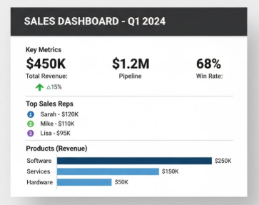

---

PART 7: TOOLS DEMO - POWER BI BASICS

Power BI

Step 1: Connect to Data
```
1. Open Power BI Desktop
2. Get Data → Excel/CSV
3. Select your file
```

Step 2: Create Visualizations
```
1. Drag "Sales" to Values → Bar chart
2. Drag "Product" to Axis → Grouped by product
3. Drag "Date" to Legend → Color by month
```

Step 3: Build Simple Dashboard
```
Page 1: Sales Overview
• Card: Total Revenue
• Bar chart: Sales by product
• Line chart: Monthly trend
```

Step 4: Publish & Share
```
1. Publish to Power BI Service
2. Share with team
3. Schedule daily refresh
```

What BAs Need to Know
1. What data sources are available?
2. What questions should dashboards answer?
3. Who needs access?
4. How often update? (Real-time vs daily)
5. Security requirements?

---

PART 8: PRACTICAL - CRM SALES DASHBOARD

Scenario: Sales Team Needs Better Visibility

Current Problem: "We can't see our pipeline. Reports take 2 days. Don't know if we'll hit target."

Requirements from Sales:
1. See my pipeline today
2. Compare vs target
3. Identify risks
4. Mobile access

Design Workshop:
Step 1: Identify Metrics
KEY METRICS:
• Pipeline value
• Win rate
• Sales cycle length
• Deal size average
• Top opportunities

Step 2: Sketch Dashboard
Mobile View (Sales Rep):
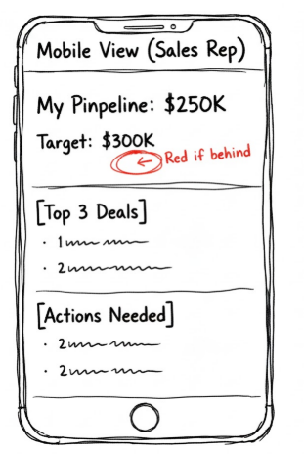

Desktop View (Manager):
[Team Pipeline: $1.2M]
[Individual Performance]
[Forecast vs Actual]
[Risk Analysis]

Step 3: Define Data Requirements
DATA NEEDED:
1. Opportunity records (amount, stage, close date)
2. Historical win/loss data
3. Sales targets
4. Activity data (calls, meetings)

Step 4: Write User Stories
As a sales rep, I want to see my pipeline
so I know if I'm on track for my quota.

ACCEPTANCE CRITERIA:
• Show current pipeline vs target
• Highlight deals at risk
• Update in real-time
• Accessible on mobile

PRACTICE:
Assignment: E-commerce Data Migration
Scenario: "StyleShop" moving from Shopify to custom platform

Data to Migrate:
- 10,000 customers
- 50,000 orders
- 500 products

Tasks:
1. List 5 data quality issues you'd check for
2. Create mapping for customer data (3 fields minimum)
3. Design 1 dashboard for inventory manager

Tool Practice:
1. Download Power BI Desktop (free)

